
Scanner
Onboarding

In order to ensure a fast onboarding process, we ask you to fill out and
return the following document to us as soon as possible.
Preferably directly to your CSM (Customer Support Manager).
If you want to connect multiple scanners, we need this
this document completed for each scanner.
With this information we can then send you a
a suitable "connector" for each of your scanners.
We would also be able to add the relevant information to our data base
for each of the scanners you wish to connect to the app.

So, please do not forget to send us this document within couple of days.
Additionally, you should also send us a photo of the monitor connection,
so that we can really send you the correct the cables and
thus avoiding any unnecessary delays.
Delivery address for the roclub connector
Customer name:
Recipient:
Address:
Postal code and City:
Country:
Scanner name
(freely selectable for display in the roclub app)
Location (optional, e.g. room name)
Manufacturer (Siemens, Philips, GE, Canon etc.)
Software version
Number of monitors (note: at the moment we only support one monitor port per connector)
Monitor connection Typ *(HDMI, DVI, Displayport, Displayport LWL)
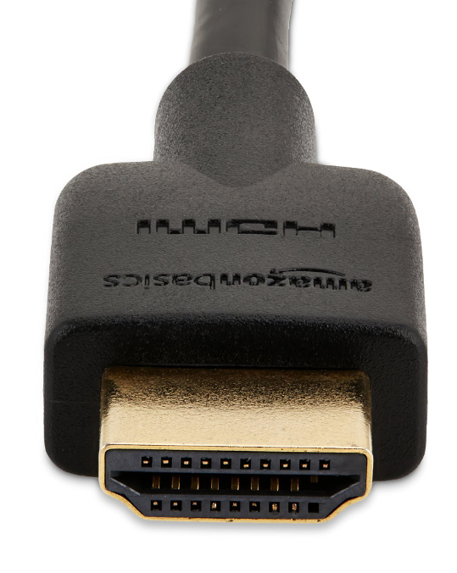  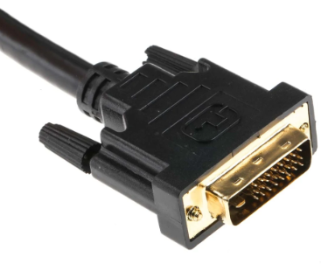  ☐ ☐ | 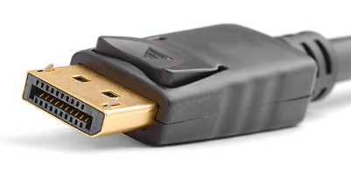  ☐ |  | 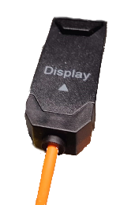  ☐
Please always check, if the monitor is connected to more than one port, which cable actually runs to the associated PC/scanner.

